Project Outline

Title (tentative): Smart Montessori School Assistance

**o Purpose (why is it being developed?)**

To replace manual/paper-based operations by automatic/computerized operations in order to achieve the following objectives:

1. to save time
2. to save daily (tedious) labor
3. to improve work-flows
4. to enhance productivity
5. to avoid mistakes (usually unavoidable in manual/paper-based operations
6. to enhance/automate communications between employees (less time, never forget, …)
7. to save $ for the owners and to relieve employees’ stresses
8. to make the business high-tech, paperless (green management, save the trees, …)

**o Applicability (who will use the system, and how will they benefit?)**

1. the owners
2. the employees
3. the parents
4. the students

**o Main Goals (which features do you need to develop?)**

1. employee attendance check in’s and out’s
2. student attendance check in’s and out’s
3. automation of educator-student ratio verification and solution
4. support for employee evaluations (simply based on employee attendance check in’s and out’s)
5. support for student evaluations and reports

**o Stretch Goals (which features would be good to have if you have time?)**

1. educational program support/management
2. …

**o Draft the main screens of your web application**

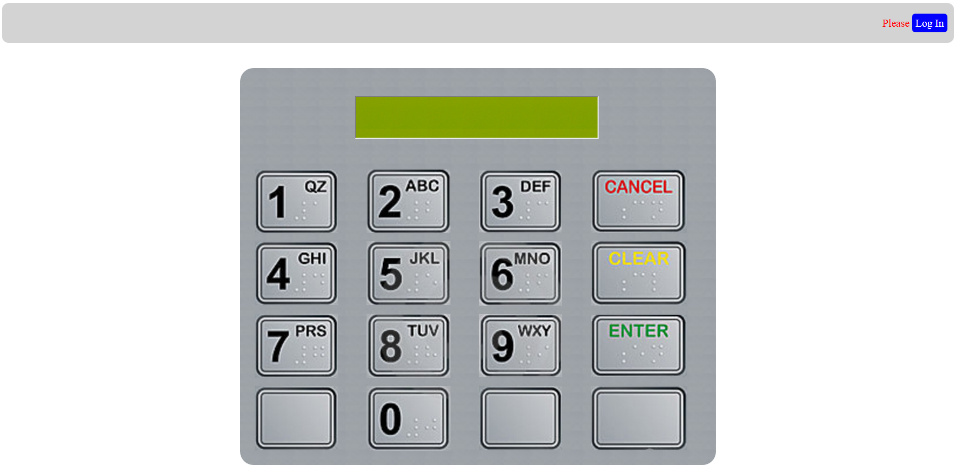

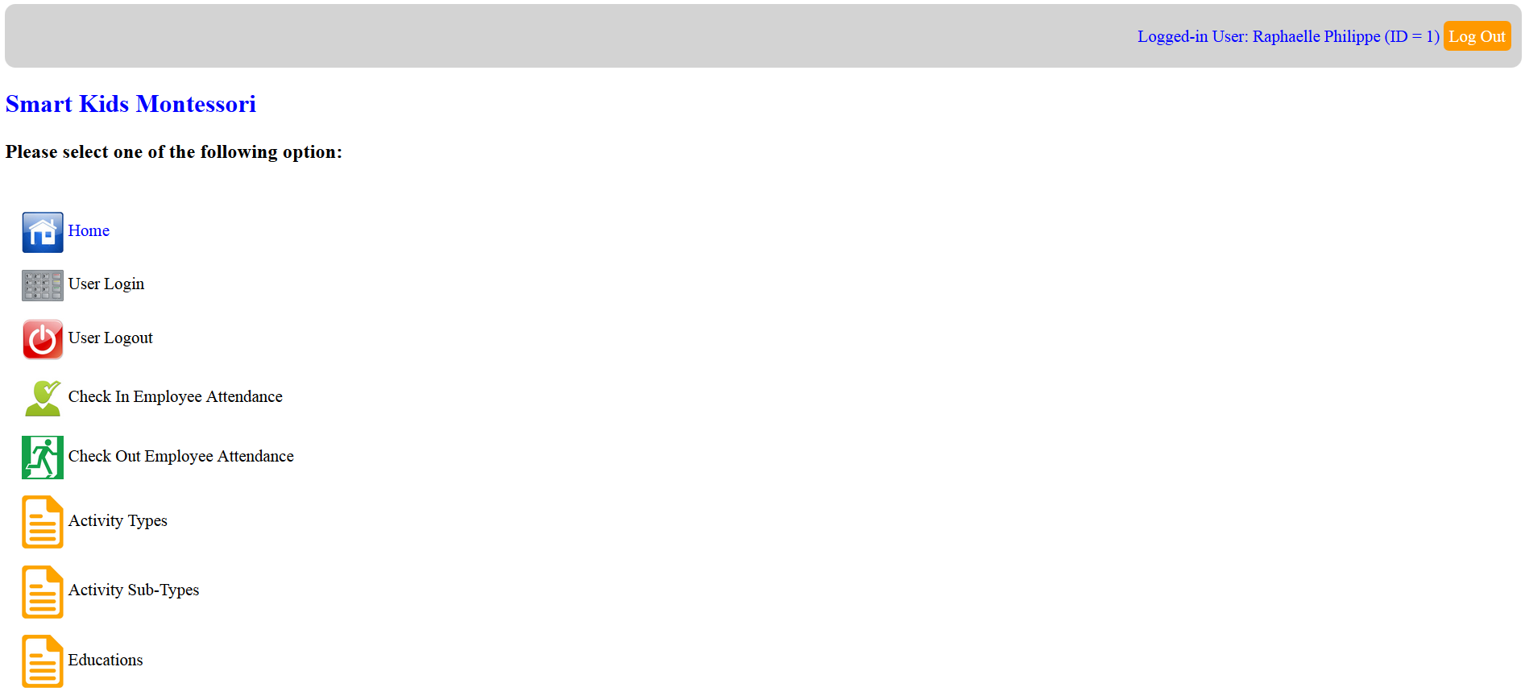

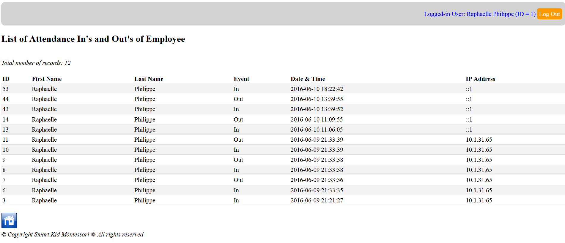

**• Database interaction**

o The project must involve

* Inserting,
* Deleting, and
* Updating data in a database, as well as
* Querying the database for output data

**o Describe**

* The data to be entered and retrieved by the user,
* The database schema,
* The forms

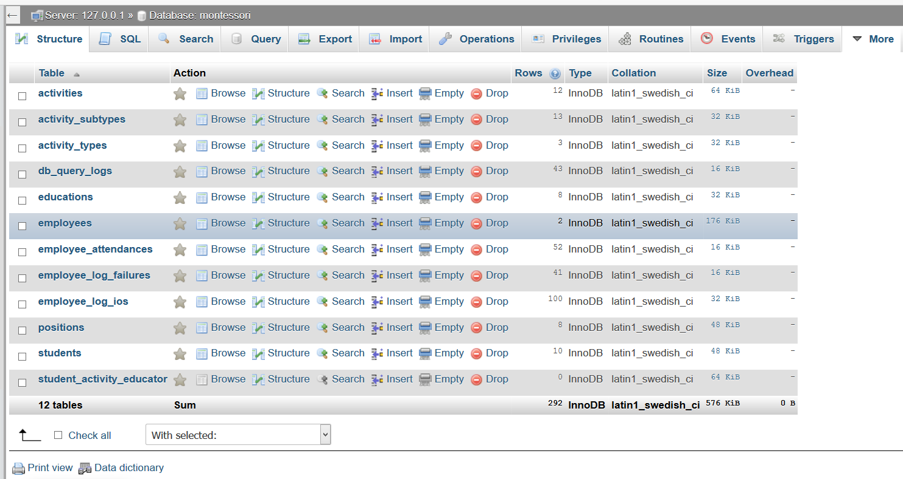

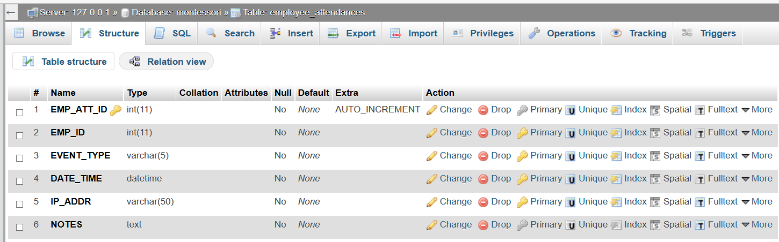

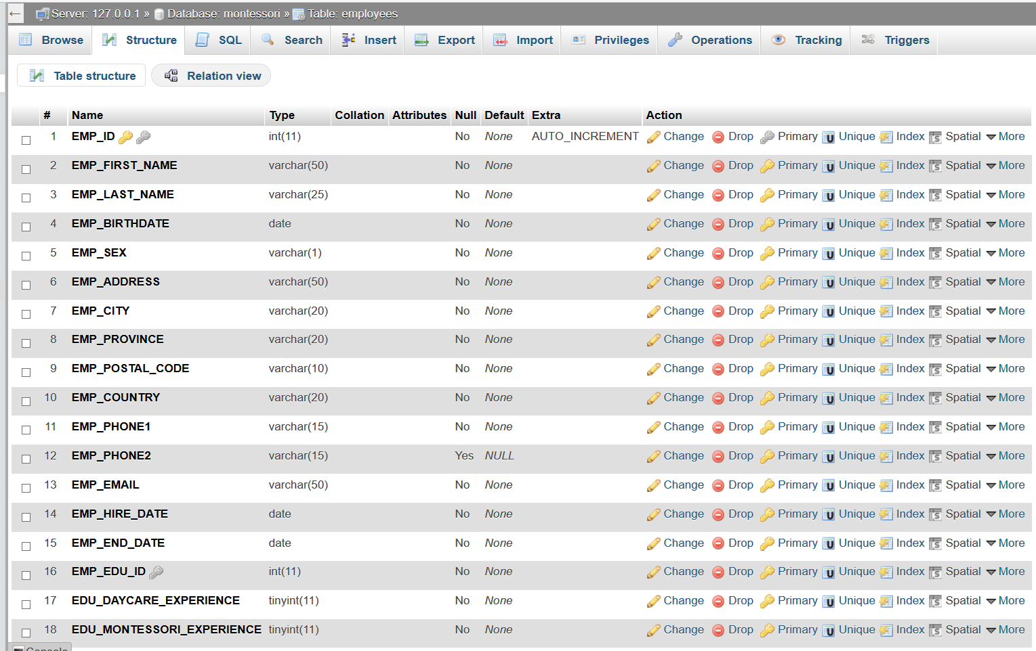

**• Project timeline**

**o List the tasks that need to be accomplished**

**o Provide an ETA (Estimate Time of Arrival) for each task**

**Week 1:**

* project proposal with objectives/scopes/desired features/…
* database design
* application/GUI design (pages, links, logic of operations, …)
* webpage framework and related library (footers, headers, mains, css, …)
* core database/SQL function library
* develop simple features
* application proof-of-concept/prototype
* preliminary tests for front-end/back-end applications

**Week 2:**

* develop advanced features
* perform various kinds of tests for front-end/back-end applications
* polish the GUIs (if time allowed)
* work on Stretch Goals (if time allowed)
* presentation and demo